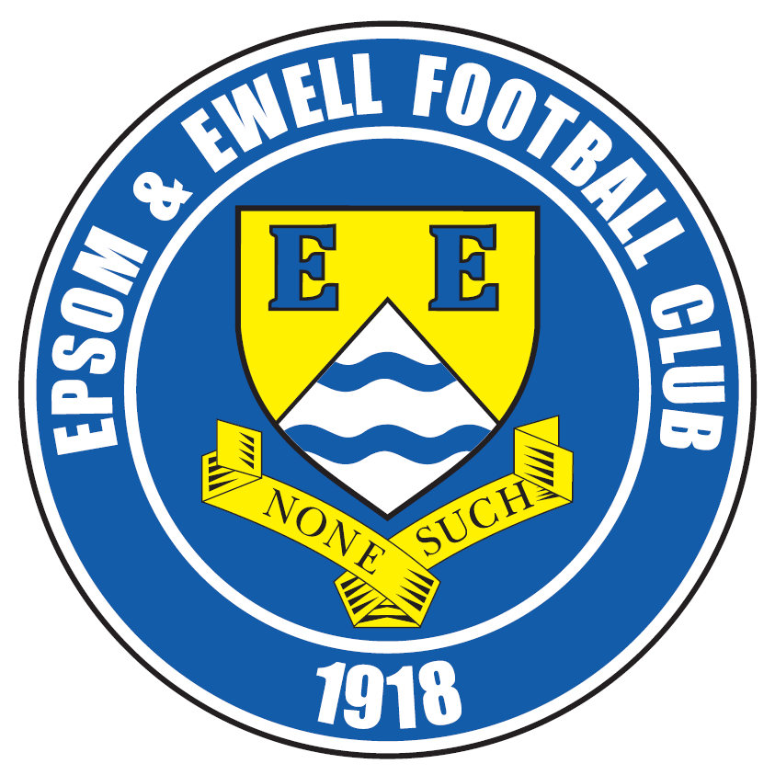 | Epsom & Ewell F.C.  24  v  Colliers Wood United  Saturday, 4th April 2015
Good afternoon! For our league match today we welcome the players and officials of Colliers Wood United, along with the match officials and of course our own regular supporters. Also, a particular hello to their Assistant Manager Paul Norris who I have known for years and who was quite a good pool player for those who didn’t know!

The two sides last met at Wibbandune way back in August, where a late goal gave the hosts a 3-2 win and since then we have had fairly similar seasons with one notable exception; the competitions. They reached the last 32 of the F.A. Vase, narrowly going out to Ascot United in the last 32, reached the Quarter-Final of the Surrey Senior Cup and were also in the Semi-Final of the League Cup on Wednesday at home to Farnham Town, but because of Easter deadlines we had to go to print before knowing the result. I hope the best team won through to face Camberley Town.

In our last home game against Westfield we recorded our fourth straight win, despite conceding an early goal. We fought back really well to lead with two goals from Kyle Hough by half time; the first of which was a superb header and we extended our lead through Sam Robinson in the second half, despite being down to ten men by that stage after the dismissal of Matt Ferdinando.

Then on Saturday, we travelled to Guildford City where the hosts were also defending a four game winning streak, so something had to give, and it was the home side that lost their record as we completed a comfortable 3-1 win there. Kyle made it seven goals in a week with another two here and now sits on thirty for the season, just one short of his highest tally for us of 31, set two seasons ago. Matt Robinson got the third goal within 23 seconds of the start of the second half and we could have had more by the end. Five straight wins and now eight unbeaten. How long can it last?

We have been lucky with fixtures this season, but it gets busy for us now as we face three away trips in the next week. We travel to Horley Town on Monday morning, to Molesey on Wednesday and Windsor on Saturday. That will leave us with just two Saturday matches left; at home to Knaphill and away to Frimley Green. Following the Frimley game on 25th April we are all meeting at the Epsom Common Working Mens Club for our end of season Presentation evening.

If you are interested, tickets cost just £10 and include your choice of meal from a selection available. Just ask any Committee member for details. The drinks are cheap and it is at a local venue so it would be really nice if we could see a lot of you all there. We start at 8pm.

One of the awards that will be presented on the night is for your Player of the Year, and voting slips are available today. If you are a club member, your choice counts as a double vote, so please let us know which players you believe are the most deserving of the award.

Enjoy the game! Glyn, the players and the club are grateful for your support.

Rich

Cover photo this week by Gemma Jarman

Kyle Hough completes his first ever home hat trick in
our 3-0 win over Badshot Lea on Saturday 21st March


Cherry Red Records
Combined Counties League
Premier Division Table 2014/15
inc Tuesday  31st March 2015 | P | W | D | L | F | A | Pts | GD | H | A
Camberley Town | 35 | 24 | 6 | 5 | 79 | 28 | 78 | +51 | 2-4 | 0-1
Molesey | 33 | 25 | 1 | 7 | 93 | 32 | 76 | +61 | 1-3 | 8/4
Ashford Town (Mx) | 35 | 23 | 3 | 9 | 87 | 50 | 72 | +37 | 2-4 | 3-1
Cove | 35 | 22 | 6 | 7 | 82 | 55 | 72 | +27 | 2-2 | 0-1
Windsor | 35 | 20 | 4 | 11 | 84 | 49 | 64 | +35 | 0-5 | 11/4
Spelthorne Sports | 35 | 18 | 4 | 13 | 68 | 59 | 58 | +9 | 4-3 | 3-0
Badshot Lea | 34 | 17 | 5 | 12 | 69 | 50 | 56 | +19 | 3-0 | 2-4
Epsom & Ewell | 34 | 16 | 4 | 14 | 66 | 58 | 52 | +8 | - | -
Hartley Wintney | 35 | 15 | 5 | 15 | 50 | 66 | 50 | -16 | 2-1 | 1-2
Colliers Wood United | 35 | 13 | 6 | 16 | 60 | 61 | 45 | -1 | 4/4 | 2-3
Farnham Town | 34 | 12 | 6 | 16 | 67 | 83 | 42 | -16 | 2-4 | 2-0
Raynes Park Vale | 33 | 11 | 7 | 15 | 44 | 56 | 40 | -12 | 0-1 | 2-0
Chertsey Town | 35 | 12 | 4 | 19 | 59 | 79 | 40 | -20 | 1-2 | 2-1
Westfield | 34 | 10 | 9 | 15 | 49 | 59 | 39 | -10 | 3-1 | 0-4
Bedfont Sports | 34 | 12 | 3 | 19 | 46 | 68 | 39 | -22 | 0-1 | 2-0
Mole Valley SCR | 35 | 11 | 5 | 19 | 57 | 88 | 38 | -31 | 1-0 | 5-2
Horley Town | 34 | 9 | 8 | 17 | 62 | 82 | 35 | -20 | 2-2 | 6/4
Knaphill | 35 | 10 | 5 | 20 | 47 | 75 | 35 | -28 | 18/4 | 4-1
Hanworth Villa | 33 | 9 | 6 | 18 | 52 | 67 | 33 | -15 | 1-1 | 5-2
Guildford City | 32 | 10 | 3 | 19 | 60 | 84 | 33 | -24 | 4-1 | 3-1
Frimley Green | 35 | 9 | 4 | 22 | 54 | 86 | 31 | -32 | 0-0 | 25/4

Lucky Day? – 4th April
Played 19 - Won 6 Drawn 2 Lost 11 - F 37 A 49 - PPG 1.05 - Poor
Club record against Colliers Wood United
Played 18 - Won 11 Drawn 2 Lost 5 - F 37 A 26 - PPG 1.94 - Very Good
Last visit
Thursday 28th March 2014 - Won 3-2 - Combined Counties League

First Eleven Appearances - (max 43 inc Guildford City)
Name | Debut | 2014/15 |  |  |  | Career Totals
Name | Debut | App | Sub | Total | Goals | App | Sub | Total | Goals
BROWN Oshane* | 30/08/2014 | 2 | 0 | 2 | 0 | 2 | 0 | 2 | 0
BURNS Robbie | 14/08/2007 | 3 | 2 | 5 | 0 | 205 | 16 | 221 | 121
COOPER-SMITH Daryl | 03/01/2015 | 5 | 3 | 8 | 3 | 5 | 3 | 8 | 3
CURRIE Sam | 04/08/2012 | 10 | 4 | 14 | 0 | 104 | 9 | 113 | 2
DEAN Dan | 02/08/2014 | 30 | 1 | 31 | 0 | 30 | 1 | 31 | 0
DEWAR Ali | 29/10/2011 | 5 | 6 | 11 | 3 | 55 | 35 | 90 | 10
DOUGLIN Karl* | 03/08/2013 | 1 | 0 | 1 | 1 | 41 | 3 | 44 | 14
DOWNS Carl* | 17/09/2011 | 4 | 1 | 5 | 0 | 94 | 13 | 107 | 2
EACOTT Michael | 02/08/2014 | 40 | 0 | 40 | 0 | 40 | 0 | 40 | 0
FARRELL Matt | 02/08/2014 | 35 | 3 | 38 | 4 | 35 | 3 | 38 | 4
FERDINANDO Matt | 20/09/2014 | 24 | 4 | 28 | 6 | 24 | 4 | 28 | 6
FRANKLIN Ben | 03/03/2015 | 1 | 0 | 1 | 0 | 1 | 0 | 1 | 0
GAFFNEY Luke* | 16/08/2014 | 10 | 1 | 11 | 0 | 10 | 1 | 11 | 0
GANNON Thomas | 28/03/2015 | 0 | 1 | 1 | 0 | 0 | 1 | 1 | 0
HARPER Tommy* | 15/04/2014 | 1 | 0 | 1 | 0 | 2 | 1 | 3 | 0
HAYWARD Ben | 07/03/2007 | 7 | 0 | 7 | 0 | 243 | 28 | 271 | 18
HOADLEY Harry | 27/08/2011 | 6 | 1 | 7 | 0 | 7 | 1 | 8 | 0
HOUGH Kyle | 14/08/2007 | 36 | 3 | 39 | 30 | 290 | 15 | 305 | 167
JARMAN Mark* | 08/08/2009 | 5 | 5 | 10 | 0 | 136 | 51 | 187 | 76
MARVELL Dale* | 15/01/2000 | 11 | 5 | 16 | 5 | 261 | 45 | 306 | 85
MCGREGOR Alex | 08/08/2009 | 14 | 2 | 16 | 1 | 171 | 56 | 227 | 27
MCKAY Alex | 20/12/2008 | 15 | 4 | 19 | 1 | 80 | 26 | 106 | 8
MURPHY George | 28/03/2013 | 22 | 1 | 23 | 1 | 63 | 5 | 68 | 3
MUTIMA Lionel* | 05/08/2014 | 4 | 2 | 6 | 0 | 4 | 2 | 6 | 0
NELMES Elliott* | 05/08/2014 | 2 | 0 | 2 | 0 | 2 | 0 | 2 | 0
PANAYI Anthony | 14/11/2010 | 35 | 1 | 36 | 0 | 162 | 15 | 177 | 4
PANAYIOUTOU Savva | 03/01/2015 | 11 | 2 | 13 | 2 | 11 | 2 | 13 | 2
ROBINSON Matt | 01/12/2012 | 19 | 2 | 21 | 4 | 20 | 5 | 25 | 5
ROBINSON Sam | 22/10/2011 | 26 | 1 | 27 | 8 | 50 | 4 | 54 | 13
ROWE Steve | 27/08/2011 | 16 | 1 | 17 | 0 | 21 | 2 | 23 | 0
SHAW Ollie* | 20/09/2014 | 0 | 10 | 10 | 0 | 0 | 10 | 10 | 0
SMITH Matt | 08/08/2009 | 0 | 1 | 1 | 0 | 91 | 43 | 134 | 10
SMITH Taylor* | 02/08/2014 | 13 | 2 | 15 | 7 | 13 | 2 | 15 | 7
TANTON Matt | 02/08/2014 | 18 | 4 | 22 | 1 | 18 | 4 | 22 | 1
TAYLOR James | 26/08/2013 | 35 | 1 | 36 | 2 | 52 | 7 | 59 | 3
VAN GELDER Julian* | 12/09/2006 | 0 | 1 | 1 | 0 | 0 | 2 | 2 | 0
WHITE Sean* | 02/08/2014 | 6 | 13 | 19 | 3 | 6 | 13 | 19 | 3
YOUNG Conor Jack | 07/03/2015 | 1 | 0 | 1 | 0 | 1 | 0 | 1 | 0
Own Goal |  |  |  |  | 1
* Player has left the club

Recent Results / Fixtures
Surrey Senior Cup Semi-Final – Tuesday 24th March
Molesey | 1-2 | Met Police
Combined Counties League – Tuesday 24th March
Bedfont Sports | 0-4 | Horley Town
Colliers Wood United | 1-1 | Raynes Park Vale
Epsom & Ewell | 3-1 | Westfield
Knaphill | 0-3 | Badshot Lea
Mole Valley SCR | 3-5 | Ashford Town (Mx)
Combined Counties League – Wednesday 25th March
Guildford City | 4-0 | Farnham Town
Combined Counties League – Saturday 28th March
Ashford Town (Mx) | 3-1 | Frimley Green
Badshot Lea | 3-0 | Raynes Park Vale
Bedfont Sports | 0-3 | Windsor
Camberley Town | 1-0 | Mole Valley SCR
Colliers Wood United | 1-3 | Hanworth Villa
Guildford City | 1-3 | Epsom & Ewell
Hartley Wintney | 2-3 | Chertsey Town
Horley Town | 2-1 | Knaphill
Molesey | 5-0 | Farnham Town
Combined Counties League Cup SF – Tuesday 31st March
Windsor | 1-2 | Camberley Town
Combined Counties League – Tuesday 31st March
Molesey | 4-1 | Chertsey Town
Spelthorne Sports | 2-1 | Raynes Park Vale
Westfield | 1-1 | Horley Town
Combined Counties League Cup SF – Wednesday 1st April
Colliers Wood United | V | Farnham Town
Combined Counties League – Saturday 4th April
Ashford Town (Mx) | V | Knaphill
Chertsey Town | V | Frimley Green
Cove | V | Windsor
Epsom & Ewell | V | Colliers Wood United
Farnham Town | V | Bedfont Sports
Guildford City | V | Camberley Town
Hartley Wintney | V | Westfield
Molesey | V | Hanworth Villa
Raynes Park Vale | V | Horley Town
Spelthorne Sports | V | Mole Valley SCR
Recent Results / Fixtures
Combined Counties League – Easter Monday 6th April - (11.30 k.o.)
Bedfont Sports | V | Ashford Town (Mx)
Camberley Town | V | Badshot Lea
Frimley Green | V | Farnham Town
Hanworth Villa | V | Spelthorne Sports
Horley Town | V | Epsom & Ewell
Knaphill | V | Hartley Wintney
Mole Valley SCR | V | Molesey
Westfield | V | Guildford City
Windsor | V | Chertsey Town
Combined Counties League – Wednesday 8th April
Molesey | V | Epsom & Ewell
Combined Counties League – Thursday 9th April
Badshot Lea | V | Hanworth Villa
Raynes Park Vale | V | Guildford City
Combined Counties League – Saturday 11th April
Bedfont Sports | V | Badshot Lea
Camberley Town | V | Ashford Town (Mx)
Colliers Wood United | V | Windsor
Frimley Green | V | Raynes Park Vale
Hartley Wintney | V | Hanworth Villa
Horley Town | V | Spelthorne Sports
Knaphill | V | Guildford City
Mole Valley SCR | V | Cove
Westfield | V | Farnham Town
Windsor | V | Epsom & Ewell
Combined Counties League – Tuesday 14th April
Badshot Lea | V | Guildford City
Farnham Town | V | Ashford Town (Mx)
Raynes Park Vale | V | Hanworth Villa
Westfield | V | Bedfont Sports
Combined Counties League – Wednesday 15th April
Colliers Wood United | V | Molesey
Combined Counties League – Saturday 18th April
Ashford Town (Mx) | V | Hanworth Villa
Badshot Lea | V | Windsor
Chertsey Town | V | Horley Town
Cove | V | Westfield
Epsom & Ewell | V | Knaphill
Guildford City | V | Colliers Wood United
Hartley Wintney | V | Mole Valley SCR
Molesey | V | Camberley Town
Raynes Park Vale | V | Bedfont Sports
Spelthorne Sports | V | Frimley Green

From behind the goal
Epsom & Ewell 3-1 Westfield
Combined Counties League - Premier Division - Tuesday 24th March 2015

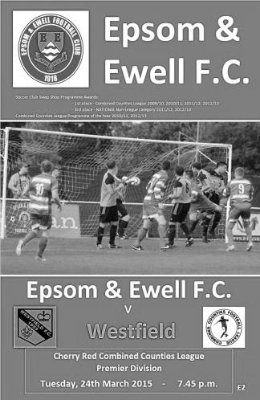
Threadbare Salts have too much quality in the end

There were many similarities with other recent scenarios during the Salts hard earned win over Westfield on Tuesday evening. There were quality goals and a lack of available substitutes, while yet again we finished the game with ten men; our tenth red card of the season. However, one further connection here is that we had won five of those previous nine matches where we finished short and so it proved once more.

Against a team in decent form and wary of our 4-0 defeat at Woking Park in September which was Glyn's first defeat as Manager, I'm sure he would have liked to have named a stronger squad, but with suspensions to Dan Dean and Matt Farrell, added to the absence on holiday of Alex McGregor, of Daryl Cooper-Smith with work, and Ali Dewar with injury, we only named the Manager, our Assistant Matt Smith and a half fit Matt Robinson on the bench. It was still a good starting line-up, we just had to hope that no injuries would befall us.

With our players aware that there were limited options available we started tentatively, not for the first time. Against Badshot Lea a great Michael Eacott save had kept them out in the early part of the match, but this time he was unable to do anything about a smart finish by James Mepham, who had to turn to receive a left foot cross that was played behind him, and with his back to goal, almost back heeled the ball into the far corner of the net. At the very least it was clever improvisation, at best it was a really skilful finish and with 7 minutes on the clock we were behind.

As time went on we started to find our feet and ten minutes after conceding Sam Robinson cut in from the left and ran in along the touch line but his pull back was blocked out at the last moment for a corner that came to nothing. We were beginning to get on top though and our equaliser came after 27 minutes. There was another similarity here if you were at our recent Chertsey match, as a free kick from a fairly innocuous position was delivered expertly onto the head of our striker. At Chertsey it was Steve Rowe to Daryl Cooper-Smith, this time it was Sam Robinson's delivery and Kyle Hough peeling away from his marker to deliver a superb header into the opposite corner, with visiting keeper Stuart Norman doing really well to even get a finger on the ball as it flew into the net.

I'm not sure how many our centre-forward has scored with his head but it's fair to say it isn't many, and five minutes later he was scoring in his more usual manner when a ball forward was sliced by a defender into his path. From the edge of the area, he cut outside the exposed Norman and slotted the ball in between two retreating defenders to put us ahead.

The turnaround was deserved, although there was a concern in between our two goals when Matt Ferdinando went on one of his runs but the ball got away from him and as he tried to reach it, caught the defender and earned a deserved yellow card. This added to another poor challenge just before the break earned him a severe warning from the referee and you felt that if we had any options on the bench, it might have been one of those days where an early substitution would be prudent, but we carried on.

The opposition, clearly annoyed at the way the game had got away from them, raised their game significantly as the half ended and by the time the whistle blew we were maybe fortunate to still be ahead. As we have found out the hard way at times this season, taking chances when you have the opportunity is vital and the visitors had a close range shot that deflected off a defender and over our crossbar, and a right wing cut in after Rowe was dispossessed, although the shot / cross in was too close to Eacott who gathered comfortably.

I am sure that at the break we would have been reminded that we needed to match Westfield in the middle of the park and in the second half we did just that. Captain Sam Currie, together with Ben Hayward who was making his first appearance for a while did a great job and held things together, enabling us to push forward and threaten further goals. Robinson volleyed a loose ball just wide of the post after Hough had been crowded out in front of goal, and although Norman got a touch on it, a goal kick was awarded.

In fact, the second half included a fair number of strange decisions. The first of which came after 54 minutes when Matt Steer went straight through the back of Hough in front of both benches. It was probably because Hough had given him the run around for much of the game, but the challenge was a bad one and having seen the incident, I was really surprised that the referee only gave a yellow card. This decision became even more contentious in the 64th minute when Ferdinando went in for a challenge and was momentarily late on a defender who hit the ground like the proverbial sack of spuds.

Whether the referee was swayed by this or the substantial pressure placed on him by the visitors we will never know, but a second yellow card followed and ended our man's game earlier than he would have liked. There is a school of thought (mine) that says it was a bit harsh, but as was stated to me at the time and by an Assistant after the game, he was already on a yellow card and a final warning so maybe needed to ensure that he didn't provide the referee with the opportunity in the first place. It's hard to argue with that line of thinking.

This was our tenth red card of the season, extending still further our recently set club record, but if there is any sort of a silver lining out of this, it is that our players were more than experienced in dealing with this type of situation by now and it's fair to say that whilst we became a little more of a counter attacking team for the remainder of the game, the overall possession remained as it had been before the sending off. In fact we should have extended our lead in the 69th minute when Savva 'Agi' Panayiotou just got a toe to the ball ahead of a defender who clattered into him. The sound of boot on boot echoed around the ground but the referee remained totally disinterested in the clearest penalty shout we have had all year and Agi, to his credit some would say, didn't really make too much of a fuss, when others would have rolled around to make sure the official saw.

Eacott made a couple of fairly routine saves from promising positions after 70 and 76 but we were looking dangerous on the break and Robinson used Hough for a one-two before curling the ball over Norman for a classy finish from twenty yards. There was a complaint of offside against Hough, but some go your way and some don't! As the game ebbed away Rowe and Robinson had shots at goal; Rowe's was powerful but just wide, whilst Robinson's was on target but lacked power and was saved easily.

In the 89th minute the visitors should have pulled a goal back when a clever ball into the right wing channel was cut back but the incoming striker missed the target from six yards. It was going to be our night and our fourth straight win too. Bonus!

Team: Michael Eacott, James Taylor, Steve Rowe, Anthony Panayi, Alex McKay, Sam Currie ©, Savva 'Agi' Panayiotou, Ben Hayward, Kyle Hough, Sam Robinson, Matt Ferdinando

Subs: none

From behind the goal
Guildford City 1-3 Epsom & Ewell
Combined Counties League - Premier Division - Saturday 28th March 2015

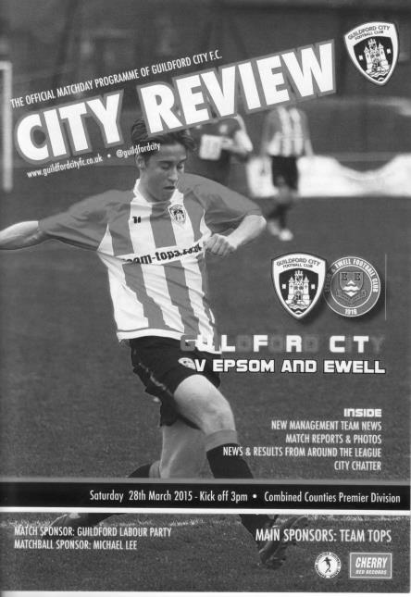
Salts maintain their winning record at the expense of Guildford's

Despite three suspended players and another worryingly light bench, our boys put in another great workmanlike performance on a difficult surface at the Spectrum. Both teams went into the game with four straight League wins but it was the Salts that emerged with their record unblemished and a win by three goals to one.

The first half an hour contained little to write about, although we possessed more of the ball. In midfield the returning Alex McGregor and Matt Robinson played, but in an area now loaded with attacking players alongside Sam Robinson and Matt Ferdinando, this meant that Savva 'Agi' Panayiotou inherited the holding midfield position and he did really well in his unfamiliar role.

Michael Eacott was the first keeper to be tested with a low shot from a wide angle after a corner had come back to the original taker but this was saved easily and we were ahead soon after. In the 33rd minute Sam Robinson put Kyle Hough through in the right hand channel and as he cut in and made for goal he was brought down. It was difficult to see what contact there had been from the distance of the main stand but there were no complaints from the opposition and Hough tucked away the penalty as he usually does.

The goal sparked the home side into life for a while and they equalised almost straight after. A ball out to the right left winger Florin Ramizi against Steve Rowe and he showed him inside before cutting back out and drilling a great low strike beyond Eacott into the far corner just four minutes after our goal.

This was harsh on our team. We hadn't created an enormous amount ourselves by this point, but had certainly not looked like conceding, even if it was a good finish. As it turned out we went in for the break 2-1 up courtesy of another Sam Robinson delivery that Hough met with his head at the far post to make it seven goals in a week and an impressive thirty for the season; just one shy of his record 31 set two seasons ago. Our

lead was extended still further just twenty three seconds into the second period as Matt Robinson got through on the left and clipped the ball just over the advancing keeper and into the net before the retreating defenders could reach it.

The pattern of the game continued as before; with the majority of possession for the visitors but with little in the way of goalmouth action. The final twenty minutes of the game were much more open though. Sam Robinson found brother Matt through on goal but his shot went just beyond the far post before a good left wing cross from Hough was attacked by Ferdinando who almost seemed to knee the ball just wide of the post!

Thomas Gannon replaced Matt Robinson to make his debut and with his first run he drew two defenders, allowing Hough to find Agi with a great run but with just the keeper to beat he lashed the ball just wide, although I think the pitch was partly responsible.

The game became a bit stretched but the only real concerns at our end were self-inflicted. In the 77th minute McGregor chose to play a back pass forty yards from the opposition's half that Eacott was just able to hack to safety ahead of an incoming striker. However, five minutes later it was our keeper's turn to hold his hands up in apology as he waited for a ball to reach the corner of his area, but upon realising that a striker would get there before it did, he chose to kick left footed, missing his shot completely, although the player probably couldn't believe his luck and promptly put his shot just wide of the far post!

We were making a number of chances by now. Ferdinando almost took advantage of a "Gerrard-like" slip and from thirty yards had a shot that went over the keeper but just wide of the far post before Hough and then Ferdinando again missed decent chances, the last of which he really should have done better with, but lobbed his effort tamely over the bar. It was fortunate that we were 3-1 ahead because on another day the missed chances would have come back to haunt us.

Eacott was well positioned to block a shot after the striker got ahead of Anthony Panayi for the only time in the game before we were back on the attack and in the final five minutes Gannon tried his luck from the edge of the area, requiring a good full stretch save from Liam Beach to stop the ball going into the top corner and from the resultant corner Panayi headed wide from a good position.

The game ended with Ferdinando blasting another chance over from close range, although in his defence he showed plenty of restraint after regularly being dumped on the ground. A late card for Luke Simmonds finally arrived as a result, about an hour after he should have had one for grabbing Hough round the neck, but the referee tried to be lenient, got the decisions correct, and as a result it was a good day all round, even for our Treasurer who had no fines to pay for the first time in a while!

Team: Michael Eacott, Sam Currie ©, Steve Rowe, Anthony Panayi, Alex McKay, Matt Robinson, Savva 'Agi' Panayiotou, Sam Robinson, Kyle Hough, Alex McGregor, Matt Ferdinando

Subs: Thomas Gannon for Matt Robinson (69)

Club Records - 4th April
Date | Day | Competition |  | Opponents |  | Scorers
04/04/25 | Sat | Friendly | H | Guildford | 4-2 | ??
04/04/31 | Sat | London League | H | Grays Athletic | 1-8 | R.Marlow
04/04/36 | Sat | London League | A | Finchley | 2-4 | J.Jones, o.g.
04/04/47 | Fri | London League | H | Eton Manor | 3-5 | D.Ralph (3)
04/04/53 | Sat | Corinthian League | H | Carshalton Athletic | 7-1 | S.Scott (3), V.Honey, D.Ford (pen), F.Lee, B.Goddard
04/04/59 | Sat | Corinthian League | H | Wembley | 1-2 | T.Millard
04/04/64 | Sat | Athenian League 1 | H | Eastbourne | 0-5
04/04/70 | Sat | Athenian League 2 | H | Marlow | 0-2
04/04/81 | Sat | Isthmian League 1 | A | St Albans City | 1-2 | L.Peck
04/04/83 | Mon | Isthmian League 1 | A | Worthing | 0-4
04/04/88 | Mon | Isthmian League 2s | A | Dorking | 2-3 | B.Perkins, L.Harding
04/04/89 | Tue | Isthmian League 2s | H | Newbury Town | 1-0 | N.Robson
04/04/92 | Sat | Isthmian League 3 | A | Bracknell Town | 1-1 | A.Webster
04/04/94 | Mon | Isthmian League 3 | H | Horsham | 1-0 | G.Morris
04/04/95 | Tue | Isthmian League 3 | H | Harefield United | 6-1 | T.Smith (3), K.Webb, P.Meredith, S.Smith
04/04/98 | Sat | Isthmian League 3 | A | Corinthian Casuals | 1-0 | A.Rawlinson
04/04/06 | Tue | Isthmian League 2 | H | Clapton | 2-2 | P.N'gbale, C.Pritchard
04/04/09 | Sat | Combined Counties Premier Division | H | Cove | 2-4 | K.Hough, D.Marvell
04/04/13 | Thur | Combined Counties Premier Division | A | Hanworth Villa | 2-3 | K.Hough (2, 1 pen)
Historical Decades
90 years ago – Epsom Town
04/04/25 | Sat | Friendly | H | Guildford | 4-2 | ??
80 years ago – Epsom F.C.
06/04/35 | Sat | London League | H | Dagenham Town | 2-1 | H.Pullen (2)
70 years ago – War time Epsom Town
07/04/45 | Sat | South Eastern  Combination | A | Tooting & Mitcham United | 2-3 | L.Dowding (2)
60 years ago – Epsom F.C.
02/04/55 | Sat | Corinthian League | A | Hounslow Town | 0-3
50 years ago – Epsom & Ewell
03/04/65 | Sat | Athenian League 1 | A | Wokingham Town | 0-3
40 years ago – Epsom & Ewell
03/04/75 | Thur | Surrey Senior League | H | Chessington United | 2-0 | P.Walker, D.Ritman (pen)
30 years ago – Epsom & Ewell
06/04/85 | Sat | Isthmian League Premier | H | Slough Town | 2-2 | T.Tuite, o.g.
20 years ago – Epsom & Ewell
04/04/95 | Tue | Isthmian League 3 | H | Harefield United | 6-1 | T.Smith (3), K.Webb, P.Meredith, S.Smith
10 years ago – Epsom & Ewell
02/04/05 | Sat | Isthmian League 2 | A | Abingdon Town | 0-3

History Corner – 4th April
67 years ago today Don Ralph scored a hat trick for us but we still lost! (see programme pictured) This 3-5 home defeat to Eton Manor was one of just eight occasions in our history when this has happened, the last being back in October 1966 when Player / Manager Tony Williams, now better known as the man behind the creation of the Non-League Yearbook scored four times in our 4-5 home defeat to Ware.
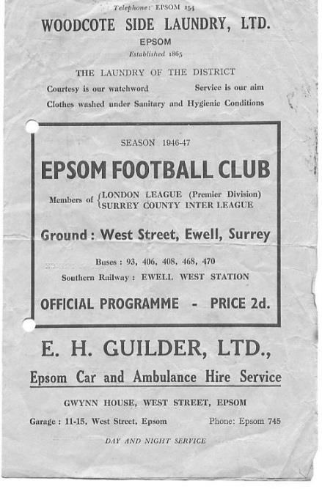
61 years ago today we were about to finish third in the Corinthian League under the Management of Player / Coach Pat Lynch. This would be our highest finish in our time with the League and was mostly secured due to the efforts of Bill Goddard who set a post war record of 54 goals, which still exists.

However, this day he only got one of our seven as Stan Scott was the man with the hat trick as Carshalton Athletic were battered 7-1 on the Easter Saturday, but this only tells half the story as the Robins were bottom of the league in February, yet stormed through winning every game except this one to become Champions of the League!

20 years ago today Tim Smith became to my knowledge, the only player to score a hat trick for us while playing as a right back! In fairness he was more a wing back that day but our largely unheralded player who went on to make over 200 appearances for us was a bullet down that flank and his three goals were added to by Steve Smith, Kevin Webb and Paul Meredith as Harefield United were blitzed 6-1 on a Tuesday evening at Merland Rise. We were a very inconsistent side though and eleven days later were only able to draw 1-1 in the return match!

2 years ago today we made our fourth visit to Hanworth Villa’s Rectory Meadows ground in confident mood. We had won on our three previous visits and with 87 minutes on the clock we were leading again by two goals to one and in complete control. However, two goals in the last few minutes gave them the win, and they would repeat the trick the following season to rescue a draw from a similarly unlikely 1-3 down. Lightning does strike twice in the same place sometimes!

Centre page for results

Centre page for results

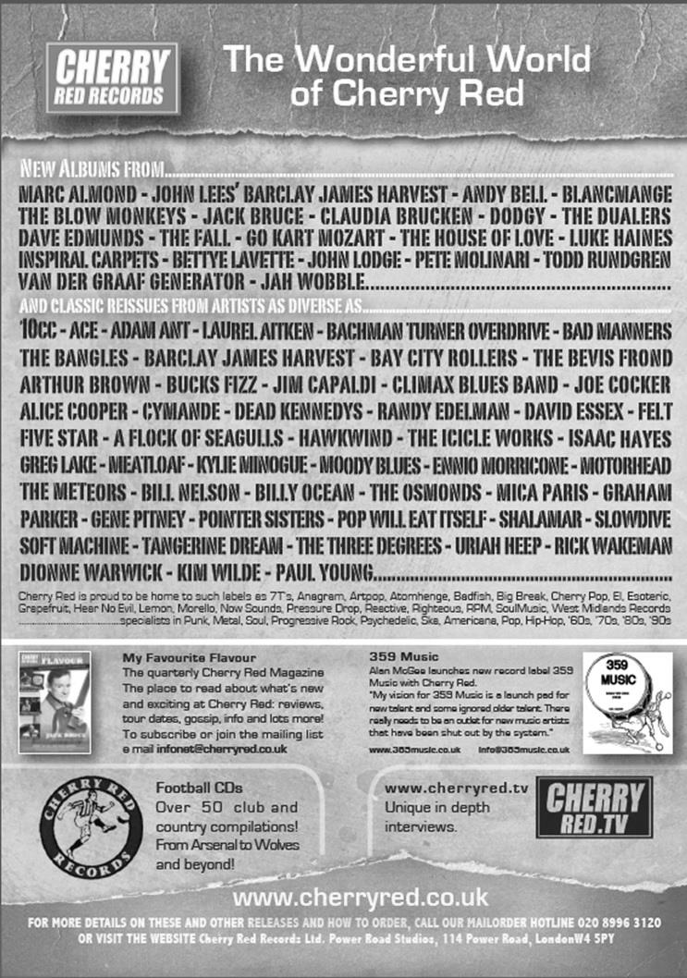

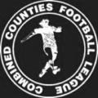

Combined Counties League

Premier Division FORM Table

Last Eight Games | W | D | L | F | A | Pts | GD | H | A
Epsom & Ewell | 6 | 2 | 0 | 18 | 7 | 20 | +11 | - | -
Molesey | 6 | 1 | 1 | 22 | 8 | 19 | +14 | 1-3 | 8/4
Badshot Lea | 5 | 1 | 2 | 13 | 5 | 16 | +8 | 3-0 | 2-4
Ashford Town (Mx) | 5 | 1 | 2 | 23 | 17 | 16 | +6 | 2-4 | 3-1
Guildford City | 5 | 0 | 3 | 19 | 14 | 15 | +5 | 4-1 | 3-1
Camberley Town | 4 | 2 | 2 | 12 | 7 | 14 | +5 | 2-4 | 0-1
Cove | 4 | 1 | 3 | 18 | 13 | 13 | +5 | 2-2 | 0-1
Hanworth Villa | 4 | 1 | 3 | 19 | 15 | 13 | +4 | 1-1 | 5-2
Horley Town | 3 | 3 | 2 | 15 | 12 | 12 | +3 | 2-2 | 6/4
Westfield | 3 | 3 | 2 | 12 | 10 | 12 | +2 | 3-1 | 0-4
Frimley Green | 4 | 0 | 3 | 10 | 10 | 12 | 0 | 0-0 | 25/4
Raynes Park Vale | 3 | 2 | 3 | 10 | 12 | 11 | -2 | 0-1 | 2-0
Windsor | 3 | 1 | 4 | 18 | 14 | 10 | +4 | 0-5 | 11/4
Colliers Wood United | 2 | 4 | 2 | 12 | 12 | 10 | 0 | 4/4 | 2-3
Chertsey Town | 3 | 1 | 4 | 18 | 22 | 10 | -4 | 1-2 | 2-1
Spelthorne Sports | 3 | 1 | 4 | 11 | 15 | 10 | -4 | 4-3 | 3-0
Hartley Wintney | 2 | 1 | 5 | 13 | 20 | 7 | -7 | 2-1 | 1-2
Farnham Town | 2 | 1 | 5 | 9 | 20 | 7 | -11 | 2-4 | 2-0
Knaphill | 2 | 0 | 6 | 12 | 15 | 6 | -3 | 18/4 | 4-1
Bedfont Sports | 1 | 0 | 7 | 8 | 20 | 3 | -12 | 0-1 | 2-0
Mole Valley SCR | 0 | 0 | 8 | 6 | 26 | 0 | -20 | 1-0 | 5-2
You can’t beat a form table when things are going your way!

And right now, they are. An excellent five game winning run enables us to look down on the rest of the League and prove what we were capable of once we had our suspended players back. In fact our last win at Guildford was achieved with three suspended players too, two of which are now eligible again so things are looking good and long may it continue.

It’s worrying for the bottom two though and as neither yet have enough points to be considered safe, they need to pick up points from somewhere or the bottom clubs will all get out at their expense!

Every Opponent A-Z
Over the years we have played many, many different opponents. Exactly how many is a difficult question, as it all depends on your definition. Are Camberley & Yorktown different to Camberley Town, or are Epsom Town different to Epsom F.C. or Epsom & Ewell F.C.?

In my analysis I have classed them as the same team, and will work through them all from A to Z. Some we have played many times, whilst others we have met just once or twice. Enjoy!


Newbury Town / AFC Newbury: Played 9 - W5 D1 L3 - F14 A6 - PPG - 1.78 - Good

We first met Newbury Town on 14th November 1987 as members of the Isthmian League Division Two South. We made the long journey to Faraday Road but didn’t see any goals in a dull encounter!

I recall the return match with more fondness as goals from Luke Harding, Steve Flack, Jimmy Richardson and Matt Elliott ensured a very comfortable 4-0 win at West Street on Saturday 27th February 1988.

Six more league encounters would follow over the next three seasons but the next was most memorable as our 1-0 win there, courtesy of a cross then looped over a defender into the net off Brian Perkins’ knee ensured our sixth straight League win. I know we have had a lot of good winning runs in recent years but back then, this was our best run since the F.A. Vase Final season fourteen seasons previously, although the run ended in a 1-1 draw at Ruislip Manor in the next match.

We repeated the score line in the return match to secure our first League double, but Newbury returned the favour the following season with a 1-0 win at West Street and a 3-0 hammering in Newbury.

Just digressing for a moment our next trip there was not for a Newbury match but a League trip to Camberley on 13th October 1990 as they had just lost their old wooden stand to fire and the Krooner Park ground was closed. We secured a very late equaliser that day.

That season we would play our final two matches against Newbury Town and this was a significant season as the two Division Two’s; South and North, were merging, and we needed a top half finish to stay in Division Two. We had an awful start to the season and in November we lost at home 1-0 but in the return match in April 1991 we registered a very creditable 2-0 win. Ultimately we fell short by two places and one point, with the main reason for our failure being the two draws we had against Camberley; a team that secured only nine points all season!

We only met once after that and by this time Newbury Town had folded (1995) and re-surfaced as AFC Newbury as a combination of three local teams but they were a poor Wessex League side at the time and we battered them 6-1 in an F.A. Cup tie at Merland Rise in August of 2005 with Jamie Goodwin scoring twice on his debut.

They too folded in the early part of 2006/07 but another local club then renamed themselves Newbury F.C. although this team now plays in the Hellenic League. They can name Brendan Rogers as a former player, with two future stars Charlie Austin and Theo Walcott having played for their Youth team back then.

North Greenford United: Played 10 - W3 D2 L5 - F14 A18 - PPG - 1.10 - Poor

Meetings with the Middlesex team have been quite recent and following our transfer to the Combined Counties League in 2006 we met them for four seasons in League action and twice in the League Cup.

Our first meeting was at Berkeley Fields on Saturday 21st October 2006. Although we lost 2-1 the abiding memory was a head injury suffered by our keeper Pierre Bourdet although he was able to play in the next match so it wasn’t quite as bad as it looked at the time.

We drew 0-0 in the return at Merland Rise but drew them away in the First Round of the League Cup in September of 2007. They had been Finalists the year before and took an early lead but a scorching strike from Robbie Burns from a wide angle into the top corner sparked us into life and James Earp put us ahead. Despite an even better strike flying past our keeper Paul Borg from nearly forty yards in the second half for the equaliser we rallied to win with Earp winning a challenge with the keeper and rolling the ball into an empty net for the winner.

We then drew there 1-1 in the League encounter in January 2008 before winning the return 3-0 in late April.

The following season we set a club record, remaining unbeaten for twelve matches at the start of the season and went there as league leaders on 1st November 2008 but they were quite good themselves and beat us 4-1 although a first half Dale Marvell hat trick; until recently the last one scored at home, was enough to see us through by three goals to two in January 2009.

Our final three meetings came in the 2009/10 season, when they were to become Champions. Unfortunately, despite still being a good side ourselves, we lost all three games, narrowly 1-0 there in the League Cup before losing for the first time at home to them, 2-0 on 31st October 2009 and they completed the League double with a 4-2 win on our final visit to Berkeley Fields on 2nd March 2010.

Their promotion to the Southern League followed and they have survived so far, although only just in some cases; being well adrift last season but just higher than Chertsey Town and Ashford Town (Mx) who came back down.

As I write, they sit at the bottom of the Southern League table and along with AFC Hayes, who we met as Brook House a few years ago, both could find themselves relegated, although whether it would be to the Combined Counties League now remains to be seen, after nearby Wembley were moved into the South Midlands League for this season. They are only a point behind AFC Hayes though, so there is still time to get out of trouble and maybe survive with a reprieve as only the bottom club is guaranteed to be moved down.

Colliers Wood United – History
The club, one of the oldest in the country, and which has now been in existence for 139 years, received a well-deserved recognition award from the FA for 125 years of playing football during 2011.

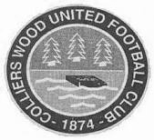
Colliers Wood United FC was founded way back in 1874 and the early years of their existence were spent in the Wimbledon and Sutton leagues before moving on to the Surrey Intermediate League (Southern Division). During the late sixties and early seventies, the club were members of the Surrey Senior League for a short time, playing in the newly formed division one where they won the league title in 1969/70.

Over the years, “The Wood” have reached a number of Surrey FA Cup Finals. In 1988/89 they lost 1-2 to Bradbank Sports in the Intermediate Cup Final and in 1991/92 they beat Woking & Horsell 4-0 in the final of the same competition.

The local recreation ground prevented the progress of the club due to the limited facilities and a search for a new ground was launched. Adequate facilities were found at Wibbandune Sports Ground in 1991 and the ground has steadily improved since then.

2001/02 saw the club enter the Surrey County Senior League where they finished a creditable 5th. The following season, they finished as runners up.

In 2002/03, the league amalgamated with the Combined Counties League and the club were founder members of the new Division 1 where they finished as runners up and were promoted to the Premier Division.

They have continued to improve. In 2004/05, they finished 14th of the 24 clubs. The following season, they finished fourth and had a fine FA Vase run, beating Chichester City United, Raynes Park Vale and Greenwich Borough, before losing to VCD Athletic in the 2nd round proper.

In 2006/07 they entered the FA Cup for the first time, defeating Chipstead after a replay before succumbing to Worthing 0-3.

After a brief ground share at Croydon FC, the club moved back to Wibbandune where ground improvements included the addition of excellent floodlighting, a new covered terrace and a 120 seat stand.

In March 2012, the club added a new away team changing room, new spectator ground lavatories and re-laid the entire playing surface including drainage thanks to a £71,000 grant from the Football Association. They also reached the 2011/12 final of the League Cup at Farnborough FC on 4th May v Guernsey FC in front of 667 spectators, which they lost 0-2 after extra time, becoming the first club to keep a 90 minute clean sheet against The Islanders.

Following a second renovation of the pitch in April, the club returned to Wibbandune in July 2013 and the under 18 youth section was re-started.

In 2014/15, Wood have reached the FA Vase 4th round (last 32 nationally) and the Surrey Senior Cup quarter finals for the first time in their history. They remain in the League Cup and were due to play Farnham Town at home on Wednesday in the Semi-Final.

EL Records Premier Challenge League Cup
Quarter Finals
Colliers Wood Utd | 3-0 | Badshot Lea
Worcester Park | 1-3 | Windsor
Epsom & Ewell | 2-4 | Camberley Town
Farnham Town | 3-2+ | Cove
Semi Finals
Colliers Wood Utd | 1/4 | Farnham Town
Windsor | 1-2 | Camberley Town
Final @ Woking F.C. – Friday 1st May
Colliers Wood / Farnham Town | v | Camberley Town

Surrey Senior Cup
Quarter Finals
Ashford Town (Mx) | 3-1 | Westfield
Colliers Wood Utd | 0-2 | Merstham
Molesey | 2-0 | Badshot Lea
Met Police | 2-1 | Tooting & Mitcham
Semi Finals
Molesey | 1-2 | Met Police
Merstham | 4-3 | Ashford Town (Mx)
Final @ Woking F.C. – Wednesday 6th May
Merstham | v | Met Police

F.A. Vase
Semi Finals – 1st leg - 21st March
Highworth Town | 0-1 | North Shields
AFC St Austell | 0-2 | Glossop North End
Semi Finals – 2nd leg – 28th March
North Shields | 3-0 | Highworth Town
Glossop North End | 0-1 | AFC St Austell
Final @Wembley Stadium – 9th May
North Shields | V | Glossop North End
Northern League | V | North West Counties

Player Sponsorship
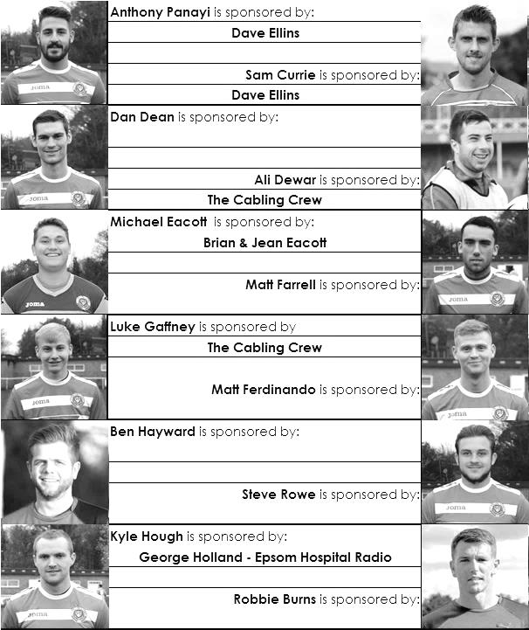

Here is the latest list showing all of the players and Management available for sponsorship. Sponsorship costs just £40 so this is your last chance this season to help the club and get your name in the programme!

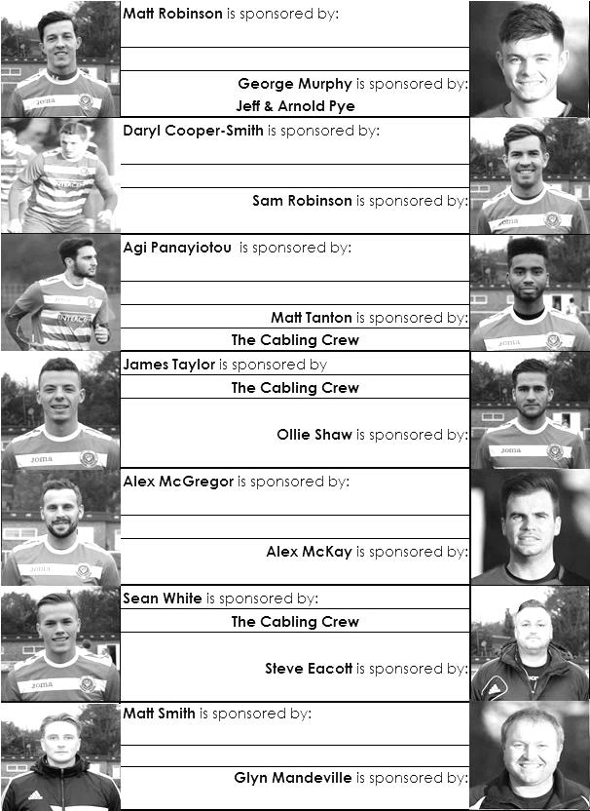

Match and Ball Sponsorships – 2014/15
Opponent | Date | Match Sponsor | Ball Sponsor
Raynes Park Vale | 05/08/14 | Club President - Stella Lamont
Horley Town | 25/08/14 | EEFC Management Committee
Croydon (FAC) | 30/08/14 | EEFC Media Officer - Richard Lambert
Frimley Green | 13/09/14 | Dave Gaffney and friends
Guildford City | 30/09/14 | The Jarman family
Mole Valley SCR | 07/10/14 | Mark and Carmel Murphy
Bedfont Sports | 11/10/14 | Epsom & Ewell F.C. Colts
Knaphill (LC) | 14/10/14 | Geoff and Steve Dyke
Ashford Town (Mx) | 18/10/14 | The Building Shop, Bookham
Chertsey Town | 28/10/14 | In Memory of Bob Bexley
Molesey | 22/11/14 | The Cabling Crew 0208 -224 4110
Camberley Town (SSC) | 02/12/14 | In memory of Liz and Doug Burns
Spelthorne Sports | 16/12/14 | long serving supporter Paul Merritt
Windsor | 03/01/15 | Ezara Beddoe
Farnham Town | 17/01/15 | In memory of Chris Henry
Camberley Town | 07/02/15 | Former player Marvin Hough
Hartley Wintney | 21/02/15 | Steve and Geoff Dyke
Camberley Town (LC) | 24/02/15 | Epsom & Ewell Colts FC
Hanworth Villa | 03/03/15 | Jeff and Arnold Pye
Cove | 07/03/15 | The Building Shop, Bookham
Badshot Lea | 21/03/15 | Vince Romagnuolo
Westfield | 24/03/15
Colliers Wood United | 04/04/15 | Nathan Lambert
Knaphill | 18/04/15
For League, League Cup and Surrey Senior Cup Matches:

Match sponsorship - £40.00 Match ball sponsorship - £25.00.
Combined Offer of Match and Match Ball sponsorship for £55.00.

For F.A. Cup and F.A. Vase matches:

Match sponsorship - £50.00 Match ball sponsorship - £30.00.
Combined Offer of Match and Match Ball sponsorship for £65.00.
----------------------------------------------------------------------------------------------------------------------------
Sponsorship includes: (x2 for match, x3 for match and ball)

Admission, programmes, hospitality and advertising and mascot for the day (if required).

If you are interested, just speak to a Committee Member, you know where we are!
Alternatively, drop me an email at: richard.c.lambert@gmail.com


Combined Counties League - Premier Division
Saturday, 4th April 2015 - Kick-off 3.00 p.m.
Epsom and Ewell  (Royal Blue & White hoops) | V |  | Colliers Wood  (Red & White Stripes/Red/Red)
 | NUMBERS
Michael Eacott |  |  | Lee Pearce
James Taylor |  |  | Sam Mead
Steve Rowe |  |  | Dan Hughes
Anthony Panayi |  |  | Tim Williams
Alex McKay |  |  | Will Boye ©
Matt Farrell |  |  | Owen Davies
© Sam Currie |  |  | Qaseem Sotoniwa
Dan Dean |  |  | Joe Mead
Kyle Hough |  |  | Charlie Emery
Sam Robinson |  |  | Mario Embalo
Savva ‘Agi’ Panayiotou |  |  | Dan Harding
George Murphy |  |  | Adam Hallissey
Matt Ferdinando |  |  | Theo Woodhouse
Matt Robinson |  |  | Eli Ogunseye
Ben Hayward |  |  | Alan Stevenson
Alex McGregor |  |  | Ahmed Farah
Daryl Cooper-Smith |  |  | Charlie Ottoway
Ali Dewar |  |  | Mark Daniels
Ben Franklin
Glyn Mandeville | MANAGER |  | Tony Hurrell
Matt Smith | ASSISTANT |  | Paul Norris
Steve Eacott / Alex McKay | COACHES |  | Dan Walker
Ken Jones | PHYSIO |  | Steve Turner
REFEREE: D.O’Shea (Aldershot)
ASSISTANTS: S.Earl (Mitcham), I.Hempel (Chessington)
The Match and Match ball are sponsored by our youngest Member,
Nathan Lambert, who was seven years old on Thursday 2nd April

OUR FINAL VISITORS TO HIGH ROAD THIS SEASON

Knaphill

Saturday 18th April 2015 - Kick-off 3.00 p.m.
Combined Counties League – Premier Division

